1. Password Less Authentication Using SSH Key

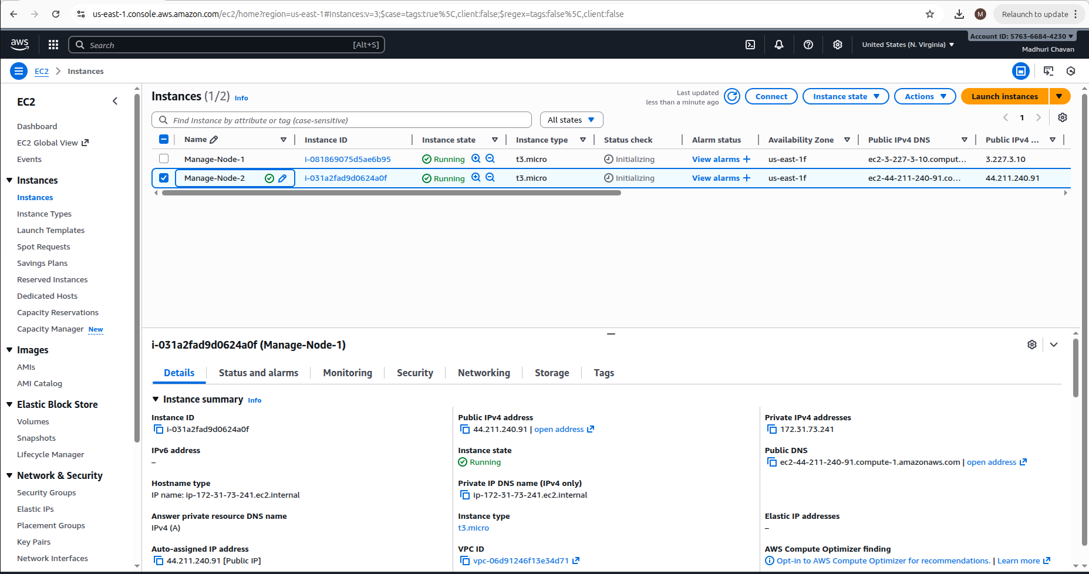

To recreate public key from existing .pem private key

ssh-keygen -y -f <path_of_pem_file> > /home/madhuri/Downloads/PasswordlessAuth.pub

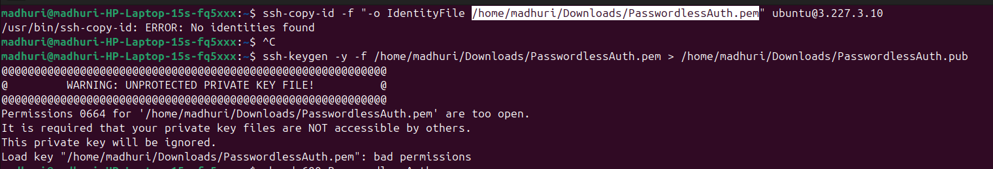
Change Permissions

Still Error while generating public Key then

ssh-keygen -t rsa -b 4096 -f /home/madhuri/Downloads/PasswordlessAuth

This will generate new key pair

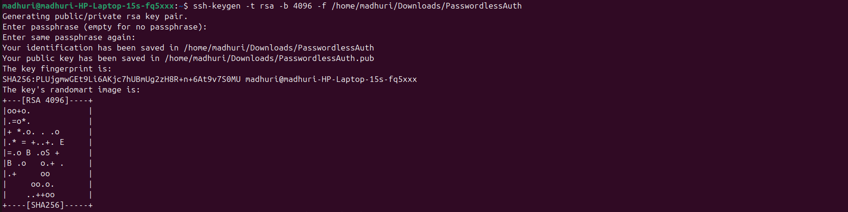
ssh-copy-id -i /home/madhuri/Downloads/PasswordlessAuth.pub ubuntu@<ip>

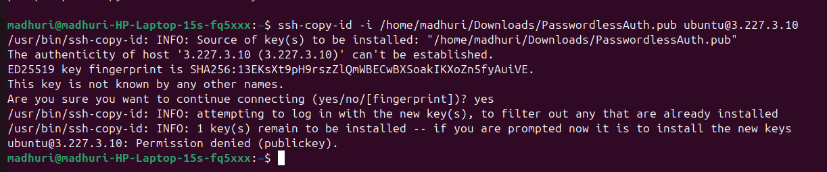
ssh -i PasswordlessAuth.pem ubuntu@<ip>

